02/01/15
THM 348 Service Operations Management
Final Exam Answer Sheet
- Ercan is the co-owner of “Asian Escape” a travel agency specialized in sending Turkish tourists to Far East countries. In his effort to improve the quality of operations at the travel agency, Ercan prepared SurvQual questionnaire and hand it to customers in the period running from 01/01/2013 till 31/12/2013. Upon analysis of said questionnaire, Ercan realized that customers spelled out their dissatisfaction in the following areas along with the frequency of those very problematic areas:
Problem Area | Frequency
Misbehavior of workers | 156
Erroneous information (Destination) | 90
Relatively high package prices | 78
Unpleasant waiting area | 66
Inadequate guide services | 54
Erroneous billing | 30
- Prepare a Pareto Chart for the above data. (2 Points)

- As “Relatively high package prices” problem had the highest frequency amongst the other problems, Ercan decided to tackle this first. He made a price comparison with major competitors and manage to design similar tours at lower costs mainly via signing more advantageous contracts with Turkish Airlines and various hotels at destination. After 12 months, he wanted to see if there are any quality improvements in the process by using a run chart. He prepared the following table depicting monthly related guests’ complaints (before / after re-negotiating contracts’). The following table reveals the results:

Month | Guest Complaints (Before) | Guest Complaints (After)
1 | 9 | 7
2 | 6 | 5
3 | 5 | 3
4 | 10 | 6
5 | 13 | 5
6 | 15 | 8
7 | 22 | 10
8 | 25 | 13
9 | 22 | 6
10 | 8 | 5
11 | 9 | 5
12 | 12 | 4
Prepare a run chart to compare guest complaints before and after re-negotiating contracts. (2 Points)

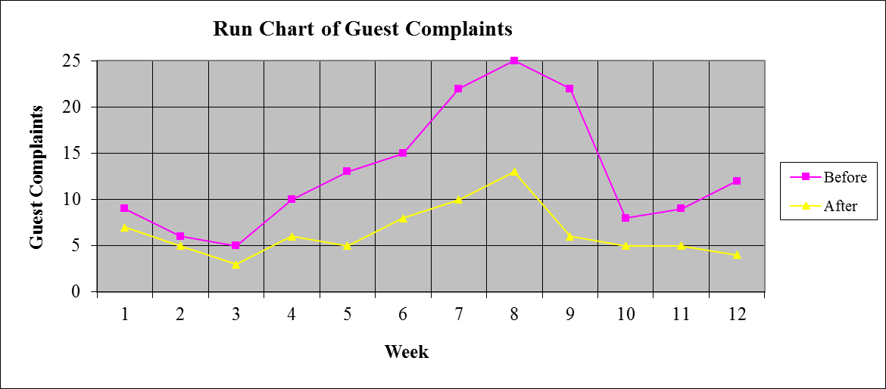
c) Analyze the finding in part b). Is there any improvement as far as guest complaints are concerned after re-negotiating contracts? If there is an improvement, what is the next problem that Ercan shall try and solve? (1 Point)
As seen from the run chart prepared in part b), there is a clear improvement as far as guest complaints are concerned after re-negotiating contracts. The next problem that Ercan shall try and solve is “Unpleasant waiting area”.

- Explain how does “Inverted T” organization charts support empowerment? (2 Points)
In inverted T organizations, the layers of supervision are drastically reduced because contact personnel are trained, motivated and supplied with timely, computer-based information that enables them to manage the service encounter at the point of delivery. Hence such types of organizations do enhance delegation of authority, hence, empowerment.
- Explain how “Service Value” drives “Customer Satisfaction”? (2 Points)
Customer value is measured by comparing results received to the total cost incurred in obtaining the service. When service value is perceived acceptable / high for customers, their expectations will be met. Hence, this creates guest satisfaction.
- During the past season, Ba Resort Hotel did not achieve very high occupancy rates despite a reservation system that was designed to keep the hotel fully booked. Apparently, prospective guests were making reservations that, for one reason or another, they failed to honor. A review of Front-desk records during the current peak period, when the Resort Hotel was fully booked, revealed the record of no-shows as shown in the below table:

No-shows | Probability | Reservations Overbooked | Cumulative Probability
0 | 0.05 | 0 | 0.00
1 | 0.06 | 1 | 0.05
2 | 0.07 | 2 | 0.11
3 | 0.08 | 3 | 0.18
4 | 0.09 | 4 | 0.26
5 | 0.10 | 5 | 0.35
6 | 0.09 | 6 | 0.45
7 | 0.10 | 7 | 0.54
8 | 0.11 | 8 | 0.64
9 | 0.12 | 9 | 0.75
10 | 0.13 | 10 | 0.87

Suppose that a vacant room (because of No Show) results in an opportunity loss of $ 50.

- Calculate the Expected Number of No Show Rooms. (2 Points)
- Expected Number of No Show Rooms = (0 * 0.05) + (1 * 0.06) + (2 * 0.07) + (3 * 0.08) + (4 * 0.09) + (5 * 0.10) + (6 * 0.09) + (7 * 0.10) + (8 * 0.11) + (9 * 0.12) + (10 * 0.13) = 0 + 0.06 + 0.14 + 0.24 + 0.36 + 0.50 + 0.54 + 0.70 + 0.88 + 1.08 + 1.30 = 5.80 Rooms.
- Calculate the Expected Opportunity Loss. (1 Point)
- Expected Opportunity Loss = 5.80 * 50 = $ 290.
In order to avoid some of this loss, Ba Resort Hotel management is considering an overbooking policy. Yet, if a guest holding a reservation is turned away (due to overbooking), other costs would be incurred. Ba Resort Hotel has made arrangements with a nearby Resort Hotel (Demba Resort Hotel) to pay for the rooms of guests whom it cannot accommodate. Further, a penalty is associated with the loss of customer goodwill and the impact this has on future business. Management estimates this total loss to be approximately $ 90 per turned out guest.
- Fill the below Overbooking Loss Table (3 Points)
 |  | Reservations Overbooked
No-shows | Prob. | 0 | 1 | 2 | 3 | 4 | 5 | 6 | 7 | 8 | 9 | 10
0 | 0.05 | 0.00 | 90.00 | 180.00 | 270.00 | 360.00 | 450.00 | 540.00 | 630.00 | 720.00 | 810.00 | 900.00
1 | 0.06 | 50.00 | 0.00 | 90.00 | 180.00 | 270.00 | 360.00 | 450.00 | 540.00 | 630.00 | 720.00 | 810.00
2 | 0.07 | 100.00 | 50.00 | 0.00 | 90.00 | 180.00 | 270.00 | 360.00 | 450.00 | 540.00 | 630.00 | 720.00
3 | 0.08 | 150.00 | 100.00 | 50.00 | 0.00 | 90.00 | 180.00 | 270.00 | 360.00 | 450.00 | 540.00 | 630.00
4 | 0.09 | 200.00 | 150.00 | 100.00 | 50.00 | 0.00 | 90.00 | 180.00 | 270.00 | 360.00 | 450.00 | 540.00
5 | 0.10 | 250.00 | 200.00 | 150.00 | 100.00 | 50.00 | 0.00 | 90.00 | 180.00 | 270.00 | 360.00 | 450.00
6 | 0.09 | 300.00 | 250.00 | 200.00 | 150.00 | 100.00 | 50.00 | 0.00 | 90.00 | 180.00 | 270.00 | 360.00
7 | 0.10 | 350.00 | 300.00 | 250.00 | 200.00 | 150.00 | 100.00 | 50.00 | 0.00 | 90.00 | 180.00 | 270.00
8 | 0.11 | 400.00 | 350.00 | 300.00 | 250.00 | 200.00 | 150.00 | 100.00 | 50.00 | 0.00 | 90.00 | 180.00
9 | 0.12 | 450.00 | 400.00 | 350.00 | 300.00 | 250.00 | 200.00 | 150.00 | 100.00 | 50.00 | 0.00 | 90.00
10 | 0.13 | 500.00 | 450.00 | 400.00 | 350.00 | 300.00 | 250.00 | 200.00 | 150.00 | 100.00 | 50.00 | 0.00
Expected | ------- | $290.00 | $247.00 | $212.40 | $187.60 | $174.00 | $173.00 | $186.00 | $211.60 | $251.20 | $306.20 | $378.00
Loss ($)
- How many rooms shall be overbooked? Why? (2 Points)
According to the above overbooking loss table, 5 rooms shall be overbooked, since, this very scenario yields the least expected loss.
N.B: Your answers to parts a), b) c) & d) shall be rounded to the nearest cent.
- Contrast “Segmenting demand” to “Promoting off-peak demand” as strategies to level capacity? Provide one example for each of the above strategies. (3 Points)
While “Segmenting demand” refer to a level capacity strategy where service operation firms dispatch its total demand into different market segments, “Promoting off-peak demand” refers to a level capacity strategy where service operation firms seek different sources of demand for its capacity in periods where the original service it at its least demanded period.
An example for segmenting demand could be airline companies that differentiate between weekday business travelers and weekend pleasure travelers. An example for promoting off-peak demand could be telephone companies which offer unlimited callings late in nights when the network is underutilized.
6. What are some of the advantages that service operation managers have when managing focused networks? (2 Points)
Some of the advantages that service operation managers have when managing focused networks can be:
- Higher growth and profits for the operation
- Maintains control over the whole operation
- Ensure consistency of service across all locations
- Reach a larger market
- Prevent imitations of the concept
- Reduce firm’s financial risk from severe, localized economic downturns.
- What are some of the issues to be accounted for when service companies opt for “Importing Customers” as a global service strategy? (3 Points)
Some of the issues to be accounted for when service companies opt for “importing customers” as a global service strategy can be:
- Choice of location
- Development of foreign language skills
- Contact personnel’s cultural sensitivity
- Transportation infrastructure
- Logistics management
- Employees’ salaries and fringe benefits
Good Luck

